AI POWERED CROP DISEASE DETECTION AND RECOMMENDATION SYSTEM FOR SUSTAINABLE DEVELOPMENT
Scope and Limitations
Department of Computer Science and Engineering, [COLLEGE NAME]
Batch C16 (CSE-C) · Academic year [ACADEMIC YEAR]
Table 1: Project team
S.No. | Student name | Roll number
1 | Pishke Vishal | 23K91A05J2
2 | Kyatham Nithisha | 23K91A05D1
3 | Mekala Tharun Kuruma | 23K91A05F1
4 | Nakka Sreenith | 23K91A05H0

Project guide: V Krishna Teja
Chapter and section numbers quoted in the text (for example Chapter 8 or Section 6.2) refer to the full project report, 17.Final Document. Figures and tables in this document are numbered from 1.

1. SCOPE

1.1 In scope
Table 2: What the project covers
Area | Included
Input | One photograph of one leaf (JPG, PNG, JPEG or WEBP, up to 10 MB) and a crop chosen from 18 options plus 'general'
Output | Most likely class of 38 (26 diseases, 12 healthy), top-3 list, severity (high, medium, none), urgent flag, symptoms, lifecycle, three treatments, prevention
Users | Anonymous visitors (disease guide) and registered farmers (diagnosis, history, exports, dashboard, analytics, profile)
Platform | Web application on a local PC, English, Hindi and Marathi interface, light and dark theme, desktop and phone widths
Data | PlantDoc (2,342 train and 236 test photographs) for the measurements; one SQLite database
Evaluation | Accuracy, top-3, macro-F1, per-class scores, confusion matrix, healthy-versus-diseased accuracy, CPU latency, API response times, automated tests

1.2 Out of scope
Table 3: What the project does not cover
Area | Not covered | Reason
Yield prediction | Not implemented | Proposed in the batch abstract; needs environmental data and a separate model
Weather advice | Not implemented | Needs an external weather service and region model
Fertiliser dosing | Treatment text only | Needs agronomist-reviewed dose tables
Voice interface | Not implemented | Outside the time available
Administrative dashboard | Not implemented | Only per-user views exist
Foliage or multi-leaf images | Single leaf only | Foliagen [1] generates foliage data; not reproduced here
A trained network in the app | Heuristic only | The CNN was trained offline (12.0 ± 0.5%); MobileNetV2 (50.3 ± 0.9%) is a reference experiment
Field trial, user study | Not done | No farmers involved; PlantDoc photographs only

1.3 Hardware and software boundary
All measurements were made on Intel Core i5-12500 (6 cores, 12 threads), 15.7 GB RAM, Windows 11 Pro, CPU only (no GPU). Software: Python 3.11.9, TensorFlow 2.21.0 (Keras 3), scikit-learn 1.5.0, OpenCV 4.11, Pillow 12.3, FastAPI, Flask 3.1, reportlab 4.1, Node 24.19, React 18.3, Vite 8, TypeScript 5.9, Tailwind CSS 4. Training times are indicative because other jobs shared the processor.

2. ASSUMPTIONS
The work rests on the following assumptions; each is stated so that a reader can judge how far the results travel.
1. The user photographs a single leaf in daylight and chooses the correct crop; the heuristic and the crop filter assume this.
2. PlantDoc photographs represent field conditions well enough to measure accuracy; they are web-scraped, of mixed quality and may contain duplicates between classes.
3. The official PlantDoc test folder is untouched by training and model selection in the experiments reported here; selection used a 10 % validation split of the training folder.
4. The knowledge base text (doses, products, prices in rupees) is general guidance written for the project; it is not region-specific and was not reviewed by an agronomist.
5. One user works on one PC; the application is a local deployment with a single backend process and one SQLite file.
6. The signing secret, ports and demo account are development defaults and are changed before any real deployment.

3. LIMITATIONS
Each limitation is given with the evidence that supports it; defect numbers D1 to D7 are used throughout the report.
Table 4: Limitations and defects
No. | Limitation | Evidence
L1 | The application ships no trained network; the heuristic engine does not diagnose. | Top-1 9.1 ± 1.0% with the crop chosen, 1.3 ± 0.7% on 'general'; chance 36.0% and 2.6%; healthy-versus-diseased 35.1 ± 0.9%.
L2 | Even the best measured model is not usable on its own. | MobileNetV2 50.3 ± 0.9%, macro-F1 0.490; several classes have F1 0 (bell pepper leaf spot, tomato bacterial spot, tomato mosaic virus).
L3 (D1) | Ten of the engine's 19 crop keys (nine of the 18 offered in the web form) make the heuristic fail. | IndexError for fewer than three candidates; API answers HTTP 400 'unreadable image'; 32.2% of test photographs unanswered (screenshot 16).
L4 (D2) | The displayed confidence is not a probability. | Floor 0.62, saturates near 97 %; the three scores sum to more than 102 % on 82% of photographs, up to 112%.
L5 (D3) | Default token-signing secret is public. | A token signed with agrivision-dev-secret-change-me is accepted unless AGRIVISION_SECRET is set (edge test).
L6 (D4) | No rate limiting on login. | Eight wrong passwords in 2.8 s were all answered (edge test).
L7 (D5, D6) | The shipped training script is unreliable. | Validates and selects on the test folder; 27 test class names against a 28-class model shift the two grape labels; docstring claims about 1.1 M parameters, measured 189,655.
L8 (D7) | Reported latency is padded. | predict() adds a constant 40 ms to the heuristic's measured time.
L9 | The data are small, imbalanced and web-scraped. | 2,342 training photographs, 2 to 180 per class, 27 test classes, 236 test photographs (about 9 per class); one test class missing.
L10 | Advice is general and unvalidated. | No agronomist review; doses are not tied to region, growth stage or area; costs are indicative.
L11 | Fertiliser, yield and weather advice, voice and admin are missing. | Proposed in the batch abstract; not present in the code.
L12 | Multilingual support covers interface strings only. | 44 translated keys; symptoms, treatments and prevention remain English (screenshot 17).
L13 | Single-leaf photographs only; the base paper's foliage setting is not addressed. | Upload takes one image; no foliage-level model.
L14 | Statistical and field validation is limited. | Three seeds, no significance test; one seed for the shipped-protocol and tuned-CNN runs; no field trial, user study or load test; UI checks not re-run in this documentation run.

Three figures illustrate the main limitations. The first shows which crop choices leave the heuristic engine with fewer than three candidate classes, so that it fails. The second shows that the confidence the application displays does not follow correctness and that the three displayed scores add up to more than 100 %. The third shows the training curves of the compact CNN, which under-fits.
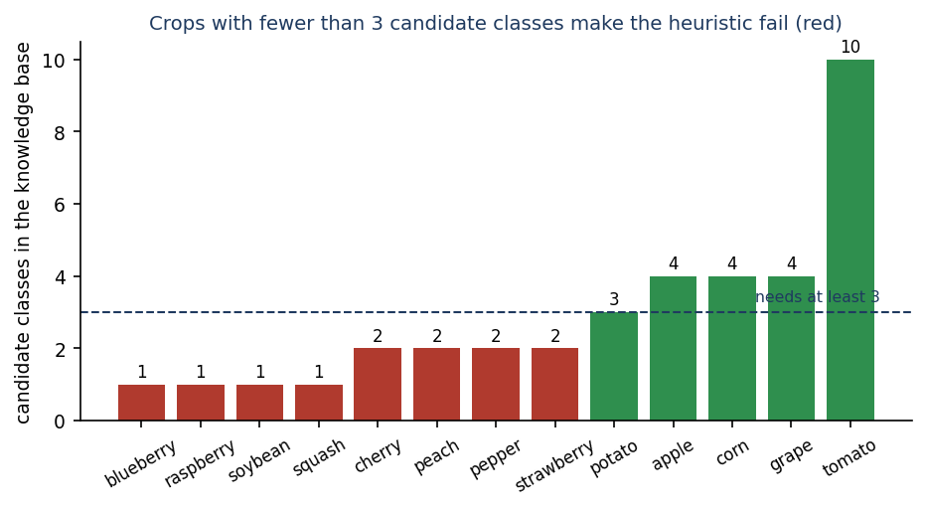
Figure 1: Candidate classes per crop option: crops with fewer than three (red) make the heuristic engine raise an error.
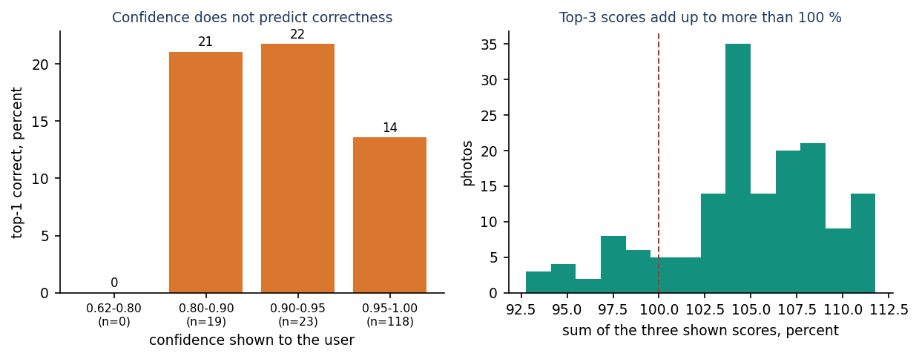
Figure 2: Displayed confidence against correctness, and the sum of the three displayed scores, for the heuristic engine on test photos.
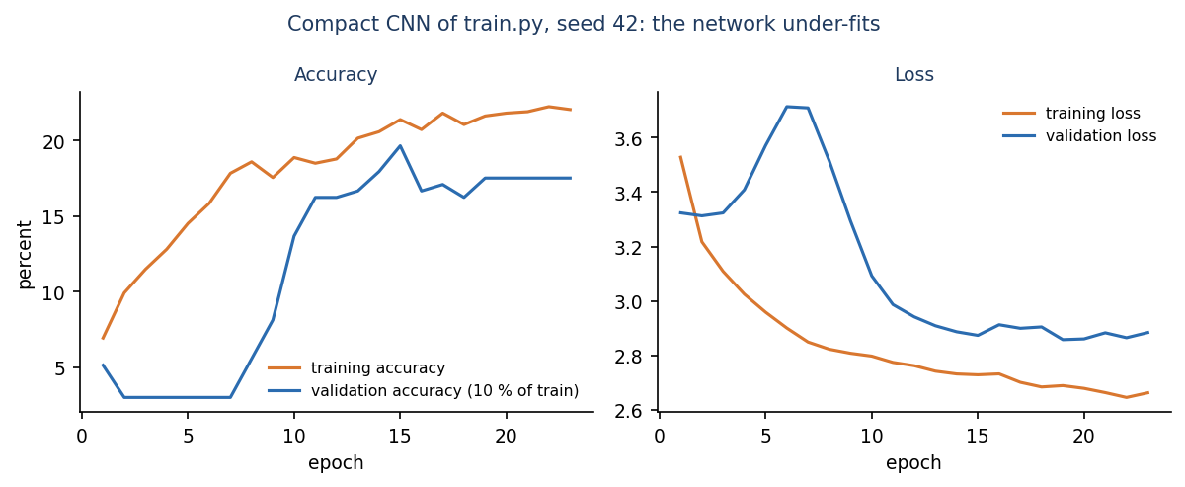
Figure 3: Training and validation curves of the compact CNN of train.py (seed 42).

4. WHAT WAS NOT MEASURED
The following were not measured, and no number is given for them in this report.
• Accuracy on photographs other than PlantDoc, on photographs taken by the team, or on crops outside the 13 PlantDoc crops.
• Agreement of the treatment advice with agronomic guidance, or its usefulness to farmers (no expert review, no user study).
• Behaviour under concurrent users or large histories (no load test); only one client on one PC was timed.
• Latency on a phone, on a GPU, or of the application when a Keras model is installed (the CNN latency of about 70 ms was measured outside the application).
• Calibration of the MobileNetV2 probabilities; probabilities of the compact CNN beyond the top-3 accuracy.
• Statistical significance of differences between models (three seeds only; the shipped-protocol and tuned-CNN runs used one seed).
• Effect of Foliagen-generated images on diagnosis of the crops covered here.
• Browser compatibility beyond Chrome in headless mode; the 55 UI checks were run in the previous session and not repeated here.
• Accessibility testing with assistive technology.

